KAYAKPRO PADDLING ERGOS.
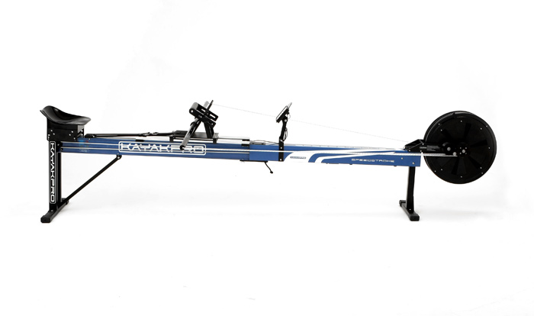
Calibrating the Console
Instructions on the use of the ergos and how to calibrate the console for each individual paddler are available alongside the working ergo. One of the ergos has a mirror in front and another to the side to enable you to check your technique whilst paddling.
When using the ergo first adjust the footrest and select the damper setting (1-9 with 9 the hardest). Next adjust the length of the shaft. The minimum length is 150cm which equates to a paddle length of 200cm. In general the shaft length should be approximately 50cm shorter than your normal paddle length.
Having made these adjustments, switch on the console by pressing (0/1). (Nb this button only switches the console on.) You can toggle between setting a time or a distance for your session in the top window by pressing the mode button (MOD). You can accept the number flashing in the top line by pressing (SET) or change it upwards by pressing (DIG) until you reach the required number. You can then accept it by pressing (SET) and the flashing number switches to the next figure. Once this has been completed for the time or distance required, you need to input your weight in kilograms by pressing the display button (DSP). The window below the mode window will now be flashing. Increase the weight shown in kilograms by pressing (SET) or reduce it by pressing (DIG) until your weight is displayed. The console now needs to be calibrated for your weight, damper setting and shaft length. Press the display (DSP) button again and the bottom left-hand window will be flashing. This indicates the current Drag Factor setting. To adjust this to meet your parameters, it is necessary to paddle hard to accelerate the fan until the revolutions indicated in the second window (where the weight was displayed) are above 700. Stop paddling at this point and allow the flywheel to run freely until it stops. The new Drag Factor will be indicated in the bottom left window. (Nb This calibration of the Drag Factor needs to be done every time the damper setting is changed, shaft length is changed, paddler weight is altered, or the batteries are changed. – effectively at the start of each session on the ergo.) Next press the ready (RDY) button and the performance window appears ready for your first session. At this point you can change the display in the second window down by pressing DSP. Each press of the DSP button allows you to switch between the 500m pace (ie estimated time/500m), watts or calories. After each effort, press (RDY) to reset the performance window to zero. To switch off the ergo and save the batteries press RDY for at least 5 seconds until the screen turns blank. (Nb The 0/1 only switches the console on)
A video explaining the instructions above is here: https://www.youtube.com/watch?v=8mM5PZMxd-Y. Please watch before using
IMPORTANT: Hold ‘RDY’ for 5 seconds to switch off
Experiments with shaft length, damper settings and stroke rates resulted in the following conclusions:
- The longer the shaft the faster the time (eg at Damper setting 1 and a stroke rate of 64 500m time dropped from 3’ 10” at 59 inches to 2’ 57” at 65 inches)
- The higher the damper setting the faster the time (eg at Damper setting 9 the 500m time dropped to 2’ 49” at a stroke rate of 64 and paddle length of 65 inches)
- The higher the stroke rate the faster the time (eg at Damper setting 9 the 500m time dropped to 2’ 39” at a stroke rate of 72 and paddle length of 65 inches.)
These conclusions resulted from work at the lower stroke rates (64-72spm). You need to do your own experiments at higher stroke rates. At some point the increase in stroke rate or paddle length will not achieve a faster time due to having reached your maximum at that setting. At this point, it may be necessary to reduce the shaft length and/or the damper setting to check whether this will enable a faster time.

How to use the Kayakpro ergo
Warm up. Because the ergo reproduces the paddling action, it can be used before a training session or competition (eg Hare & Hounds) as part of a warmup. Calibrating the console is not strictly necessary for this activity
Fitness Training Session. All of the sessions indicated in the training programme can be conducted on the ergo. This is useful if there is ice on the canal or the weather is awful (ie wet, windy and/or cold). Calibrating the console will ensure that your performance on the ergo will match that in the kayak. As performance in the kayak is affected by the type and weight of the kayak and by environmental factors such as water temperature, water depth and wind speed and direction, performance on the ergo is more consistent as it is independent of boat type/weight and of environmental factors and therefore allows improvements in performance to be measured more easily
Calculating your racing handicap. You will need to experiment to find the optimum setting of the damper, shaft length and strokes per minutes to provide an accurate calculation of your racing handicap over 200m, 500m and 1000m. This handicap can be reassessed every month to monitor the effects of your training.
Time trialling. The ergo enables you to experiment with different strategies to see how they affect the overall time for whatever distance you wish to train for. Usually, the aim is for an even split where the second half is completed in the same time as the first. This suggests an even pace throughout but this only applies over the middle cruise phase. Every race distance has a start phase, cruise phase and finish phase. As everything is equal each time, you can see the effect of different lengths of the start phase (eg 30 seconds, 1 minute, 2 minutes etc) at higher stroke rates than the cruise phase before the transition down to your optimum cruising stroke rate for the distance and then the effect of different lengths of the finish phase when the stroke rate is again increased as high as possible.
Power Training. The ergo can be used to develop power by using a long shaft and damper setting 9. This is the equivalent of adding weight to the boat or paddling with a bungee. Calibrating the console will allow any improvement to be measured
Overspeed Training. The ergo can be used for overspeed training at higher strokes per minute than you are used to by shortening the shaft and lowering the damper setting. For example, the stroke rate in a K2 is higher than in a K1 so if you always training in a K1 you will struggle with the higher stroke rate in a K2 unless you introduce more K2 training or use the ergo. This is even more relevant for training for K$ races as these are not usually available in clubs for training.
Technique Training. The ergo provides a stable platform to enable you to work on aspects of your paddling technique without the fear of a capsize. It is ideal for beginners to enable them to learn good technique before they start in a boat. The large mirror in front and the smaller one to the side enables you to see what you look like when you are paddling while it happens without having to look at a video afterwards

Introduction to Racing Kayaking. The ergos can be used in the paddlesport stage of a young paddler’s development. It can be used to set time or distance challenges. Establishing a handicap time for 200m, 500m and/or 1000m can indicate to paddlers on Paddlepower courses or taster sessions their potential as racing paddlers and help encourage them to be part of the racing section of the club and join in with the regular training sessions

Rehabilitation. The ergo enables a return to paddling under controlled conditions after illness or injury.

Circuit Training. The ergos, both the Kayakpro and the Lawler Incline Ergo, can be incorporated into a fitness training circuit

